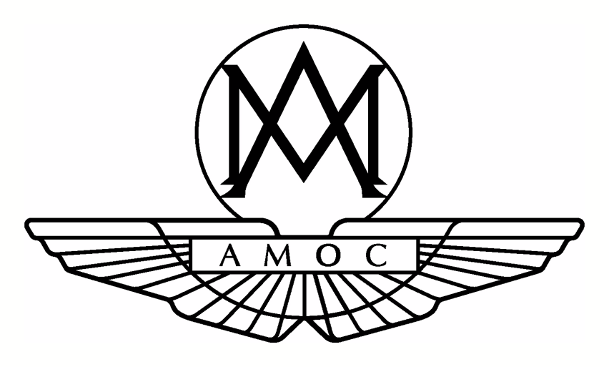
REGULATIONS GOVERNING ASTON MARTIN CARS IN SPEED EVENTS FOR 2023
The following regulations cover Aston Martin cars in the various competitions organised by the Aston Martin Owners Club in the UK and supersede any previous regulations.
While many people feel that our cars should be kept as close as possible to their original specification, there are those who already have cars that have been changed from the way they left the factory, and others who wish or need to alter them. It is not the Club’s aim to restrict or try to control such changes, but to channel members’ enthusiasm in such a way that the resulting cars neither look absurdly anachronistic, nor gain unfair competitive advantage from the use of modern technology and materials. The Speed Series Officials, who retain absolute discretion as to classification, will interpret these rules with the above in mind, rather than in a strictly legalistic fashion.
All cars must comply with the Technical Regulations of Motorsports UK for the type of competition being entered, and the following regulations are supplementary to these Technical Regulations. All minimum weights are to be taken post-race. All competitors must complete and sign a declaration form for the car/cars they intend using, prior to competing in a Sprint Programme event. The rules are divided into the following groups, each of which is sub-divided into categories:
In General, unless the rules say you can, you cannot
Class 1
Vintage and Venerable (PVT) Aston Martins in two categories - A is for standard cars, B is for modified cars.
Class 2
David Brown Aston Martins - DB1, DB2, DB2/4 Mk I, Mk II, DB Mk III, DB3 DB3S. The class will be subdivided into two categories – A: standard cars, B: modified cars.

Class 3
David Brown Aston Martins - DB4, DB5, DB6, DBS (6 cylinder cars only), DBR1, DBR2, DBR4, DB4GT & Project Cars (including R Category cars). The class will be subdivided into two categories - A: road cars series production, B: modified cars series production.
Class 4
All Newport Pagnell V8 engined Aston Martins and Lagonda’s - V8, Virage, V12 Vanquish, and Bloxham DB7’s.The class will be subdivided into two categories -A: road cars series production, B: modified cars series production.
Class 5
All Gaydon production cars - DB9, V8 Vantage, V8 Vantage S, Rapide, DBS, V12 Vantage, V12 Vantage S, Vanquish, N24, GT4, DB11, Vulcan. DBS Superleggera. The class will be subdivided into two categories - A: road cars series production, B: modified cars series production.

Class 6 Invitation – If there is an aspect of your car which is outside of these rules, or you wish to run as an invitation class car, you should apply to the Speed Series Officials for a letter of dispensation. The dispensation – if granted - will be applicable to the individual car in question and is valid for a period of one year only.

NB: for full information and specification regarding the requirements for each class, please click on the appropriate link on the website.

